MODEL
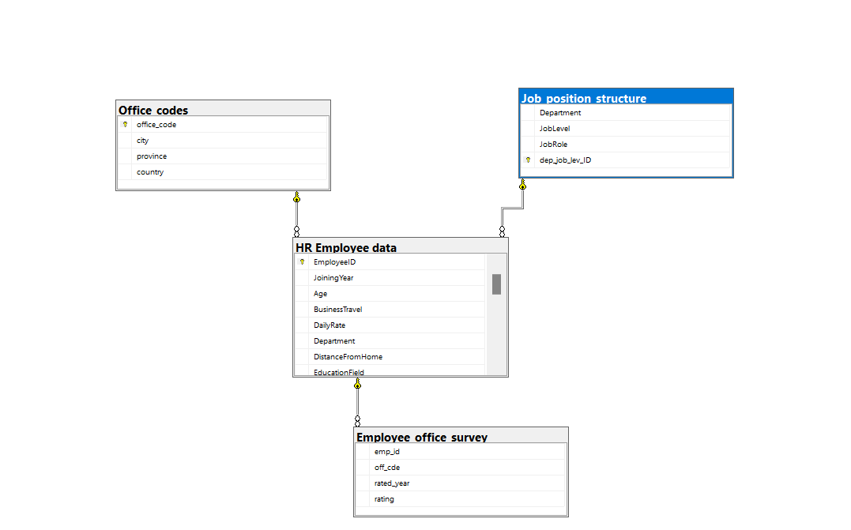

-- 1. Find employees who have more than 5 years of experience and work overtime
SELECT
EmployeeID,
dep_job_lev_ID
FROM
[HR Employee data]
WHERE
TotalWorkingYears > 5 AND OverTime = 'Yes'
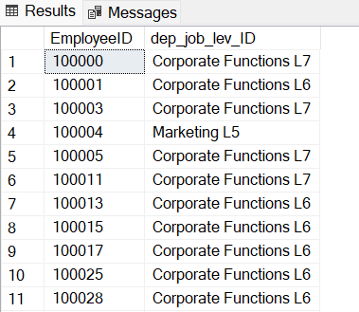

-- 2. Show average rating per office for the last 3 years

WITH MaxYear AS (
SELECT MAX(rated_year) AS max_year
FROM Employee_office_survey
)

SELECT
oc.office_code,
AVG(eos.rating) AS avg_rating
FROM
Office_codes oc
LEFT JOIN [HR Employee data] hr
ON oc.office_code = hr.office_code
LEFT JOIN Employee_office_survey eos
ON hr.EmployeeID = eos.emp_id
JOIN MaxYear my
ON eos.rated_year BETWEEN my.max_year - 2 AND my.max_year
GROUP BY oc.office_code
ORDER BY AVG(eos.rating) DESC

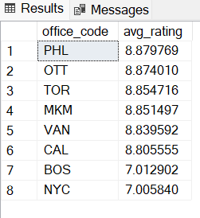

-- 3. Find employees with the highest JobSatisfaction and the lowest MonthlyIncome (lowest income up to + 100 dollars)

WITH Max_job_satisf AS (
SELECT MAX(JobSatisfaction) AS MaxSatis
FROM [HR Employee data]
),
MinIncomeValue AS (
SELECT MIN(MonthlyIncome) AS MinInc
FROM [HR Employee data]
)

SELECT
EmployeeID,
JobSatisfaction,
MonthlyIncome
FROM [HR Employee data], Max_job_satisf, MinIncomeValue
WHERE
JobSatisfaction = MaxSatis
AND MonthlyIncome BETWEEN MinInc AND (MinInc + 100)

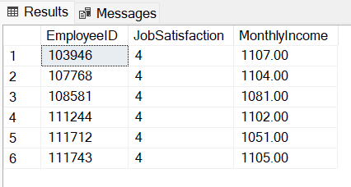
-- 4. Show the number of employees who left the company by reason for leaving

SELECT
Reason,
COUNT(EmployeeID) AS Number_of_Employees
FROM [HR Employee data]
WHERE Attrition = 'Yes'
GROUP BY Reason
ORDER BY Number_of_Employees DESC;

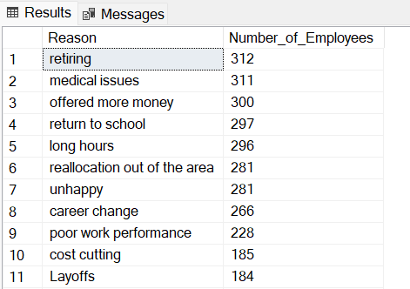

-- 5. How many employees are there in each combination of department and job role?

SELECT
jps.Department,
jps.JobRole,
COUNT(hr.EmployeeID) AS Number_of_Employees
FROM
Job_position_structure jps
JOIN
[HR Employee data] hr
ON jps.dep_job_lev_ID = hr.dep_job_lev_ID
WHERE
hr.Attrition = 'No'
GROUP BY
jps.Department,
jps.JobRole
ORDER BY
Number_of_Employees DESC;

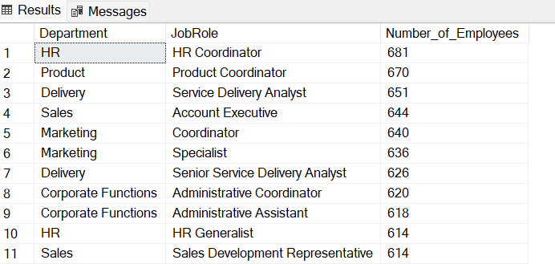

-- 6. Show the total number of employees by category of number of companies they worked for (categories to be created in the query)

SELECT
MAX([HR Employee data].NumCompaniesWorked) AS Max_num_companies_worked,
AVG([HR Employee data].NumCompaniesWorked) AS Avg_num_companies_worked,
MIN([HR Employee data].NumCompaniesWorked) AS Min_num_companies_worked
FROM
[HR Employee data]

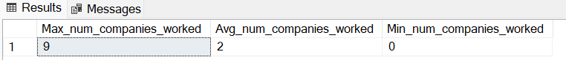

SELECT
CASE
WHEN NumCompaniesWorked <= 2 THEN '0-2 companies before'
WHEN NumCompaniesWorked BETWEEN 3 AND 5 THEN '3-5 companies before'
WHEN NumCompaniesWorked > 5 THEN 'a lot of companies before'
END AS CompaniesWorkedCategory,
COUNT(EmployeeID) AS Number_of_employees
FROM
[HR Employee data]
GROUP BY
CASE
WHEN NumCompaniesWorked <= 2 THEN '0-2 companies before'
WHEN NumCompaniesWorked BETWEEN 3 AND 5 THEN '3-5 companies before'
WHEN NumCompaniesWorked > 5 THEN 'a lot of companies before'
END
ORDER BY Number_of_employees DESC;

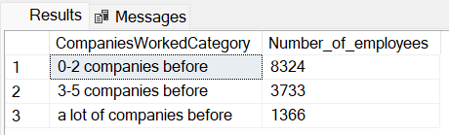
-- 7. Show the number of employees by education level who received their last promotion within 5 years or less, and who have been with the company for less than 9 years

SELECT
EducationField,
COUNT(EmployeeID) AS Number_of_employees
FROM
[HR Employee data]
WHERE
YearsSinceLastPromotion <= 5 AND
YearsAtCompany < 9
GROUP BY
EducationField
ORDER BY
COUNT(EmployeeID) DESC

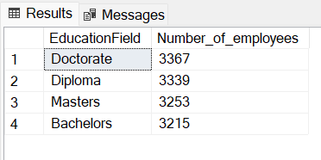

-- 8. Show the number of employees by department and country

SELECT
country,
Department,
COUNT(EmployeeID) AS Number_of_employees
FROM
[HR Employee data]
JOIN Employee_office_survey ON [HR Employee data].office_code = Employee_office_survey.off_cde
JOIN Office_codes ON Employee_office_survey.off_cde = Office_codes.office_code
GROUP BY
country, Department
ORDER BY
COUNT(EmployeeID) DESC

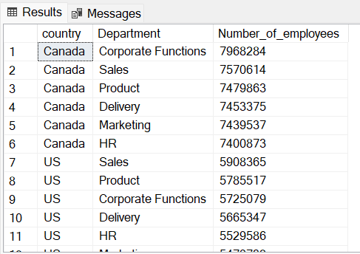

-- 9. Show all employees who had JobSatisfaction below 3 and PerformanceRating below 3

SELECT
EmployeeID
FROM
[HR Employee data]
WHERE
JobSatisfaction < 3 AND
PerformanceRating < 3

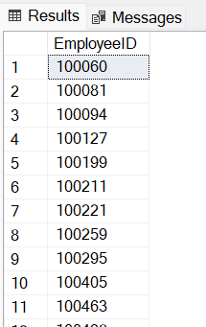

-- 10. Show all offices that have at least one employee with a rating of 5

SELECT
DISTINCT HighPerformers.office_code AS office_codes
FROM

(SELECT
*
FROM
[HR Employee data]
WHERE
PerformanceRating = 5) AS HighPerformers

JOIN Employee_office_survey ON HighPerformers.office_code = Employee_office_survey.off_cde
JOIN Office_codes ON Employee_office_survey.off_cde = Office_codes.office_code
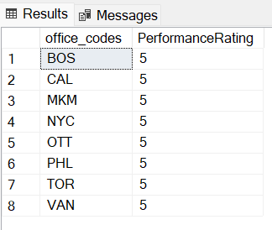

-- 11. Find employees who have OverTime = 'Yes' and WorkLifeBalance = 1

SELECT
EmployeeID,
OverTime,
WorkLifeBalance
FROM
[HR Employee data]
WHERE
OverTime = 'Yes' AND WorkLifeBalance = 1

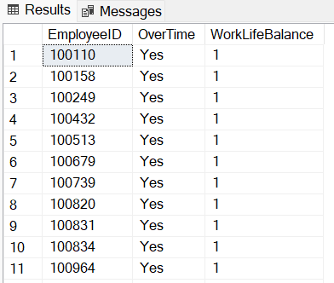
-- 13. Show average age by department

SELECT
jps.Department,
AVG(hr.Age) as Average_Age
FROM
Job_position_structure jps
JOIN
[HR Employee data] hr
ON jps.dep_job_lev_ID = hr.dep_job_lev_ID
GROUP BY
jps.Department
ORDER BY
AVG(hr.Age) DESC
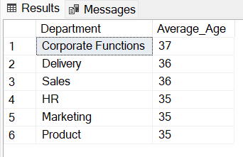

-- 14. Show the top 5 highest paid employees per office

WITH CleanedData AS (
SELECT DISTINCT
eos.off_cde,
hr.EmployeeID,
hr.MonthlyIncome
FROM
Employee_office_survey eos
JOIN
[HR Employee data] hr
ON eos.emp_id = hr.EmployeeID
),

Top5ByOffice AS (
SELECT
off_cde,
EmployeeID,
MonthlyIncome,
ROW_NUMBER() OVER (
PARTITION BY off_cde
ORDER BY MonthlyIncome DESC
) AS RowNum
FROM
CleanedData
)

SELECT
off_cde,
EmployeeID,
MonthlyIncome,
RowNum
FROM
Top5ByOffice
WHERE
RowNum <= 5
ORDER BY
off_cde,
RowNum;
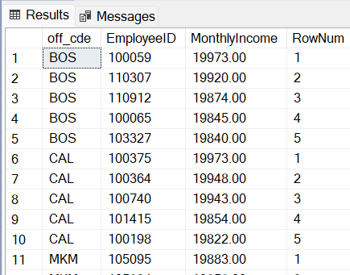

-- 15. Pivot the Employee_office_survey table so you can easily see the change of average rating per office year by year.

SELECT
off_cde,
AVG(CASE WHEN rated_year = 2017 THEN rating END) AS Year_2017_AvgRating,
AVG(CASE WHEN rated_year = 2018 THEN rating END) AS Year_2018_AvgRating,
AVG(CASE WHEN rated_year = 2019 THEN rating END) AS Year_2019_AvgRating,
AVG(CASE WHEN rated_year = 2020 THEN rating END) AS Year_2020_AvgRating,
AVG(CASE WHEN rated_year = 2021 THEN rating END) AS Year_2021_AvgRating,
AVG(CASE WHEN rated_year = 2022 THEN rating END) AS Year_2022_AvgRating,
AVG(rating) AS Average_rating_all_years
FROM
Employee_office_survey
GROUP BY
off_cde

